1.

a) GET metodom

b) 50ms za najkraci, 653 milisekunde za najduzi

c) Request headeri:

|  |  |
| --- | --- |
| Accept | image/avif,image/webp,*/* |

|  |  |
| --- | --- |
| Accept-Encoding | gzip, deflate, br |
| Accept-Language | en-US,en;q=0.5 |
| Connection | keep-alive |
| Cookie | _ga=GA1.3.40214900.1666780573; _gid=GA1.3.1748022760.1666780573; GATSBY_LOCALE=bs |
| Host | etf.unsa.ba |
| Referer | <https://etf.unsa.ba/> |
| Sec-Fetch-Dest | image |
| Sec-Fetch-Mode | no-cors |
| Sec-Fetch-Site | same-origin |
| User-Agent | Mozilla/5.0 (X11; Ubuntu; Linux x86_64; rv:105.0) Gecko/20100101 Firefox/105.0 |

Response headers

|  |  |
| --- | --- |
| accept-ranges | bytes |

|  |  |
| --- | --- |
| content-length | 939 |
| content-type | image/png |
| date | Wed, 26 Oct 2022 10:36:22 GMT |
| etag | "6357f3d8-3ab" |
| last-modified | Tue, 25 Oct 2022 14:34:00 GMT |
| server | nginx/1.23.2 |
| X-Firefox-Spdy | h2 |

Ovo ucitava flavicon stranice

d)

|  |  |
| --- | --- |
| User-Agent | Mozilla/5.0 (X11; Ubuntu; Linux x86_64; rv:105.0) Gecko/20100101 Firefox/105.0 |

e) Ukupno je 71 request

2a. Headeri 2.a.3.(a)

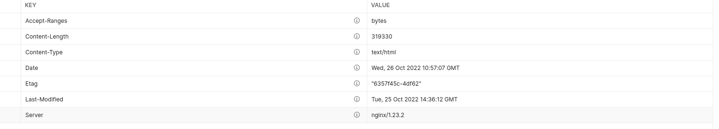2.a.3.(b) Status 400 Bad Request

2.a.3.(c) Time

The request cannot be fulfilled due to bad syntax.

EVENT

TIME

Prepare

5.61 ms

Socket Initialization

0.09 ms

DNS Lookup

3.5 ms

TCP Handshake

3.12 ms

SSL Handshake

4.86 ms

Transfer Start

544.56 ms

Download

4.61 ms

Process

0.1 ms

Total

566.4 ms

2.a.3.(d)

text/html

2.b.(a)

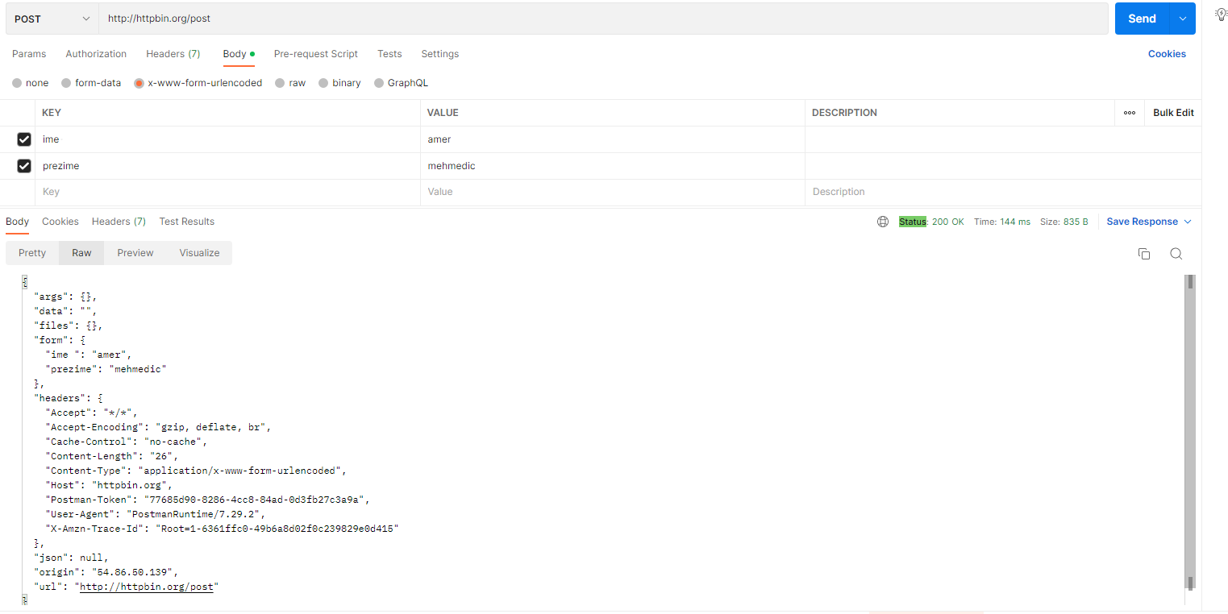

2.b.(b)

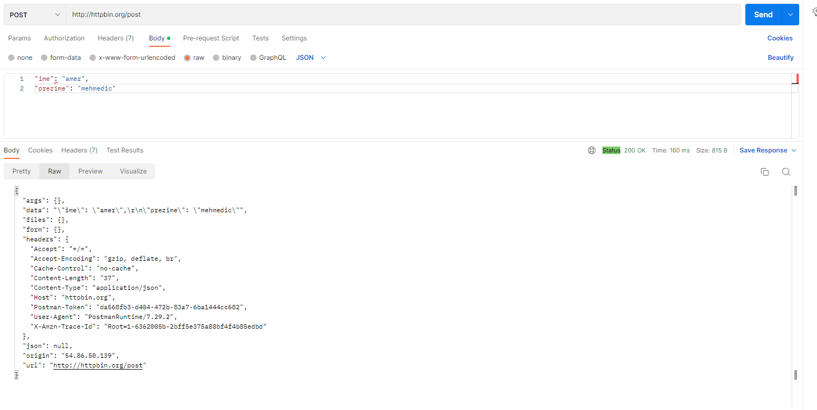

2.b.(c)

